Python Exercises Week 4

Complete each exercise as it own separate.py file named after the exercise number. For example, ***exercise_1.py***

Zip all exercise files in one folder named ***last_name_exercise_week_9.zip and submit to the appropriate drop box.***

Exercise 1 (5):

Write a program that requests an hourly worker’s name, hours worked, and hourly wage, and then calculates his or her week’s pay.

The program should contain a class named Wages with instance variables (constructor) for a worker’s name, hours worked, and hourly wage, and a method named payForWeek.

Note: Federal law ­requires that hourly employees be paid “­time-​­and-​­a-​­half” for work more than 40 hours in a week.

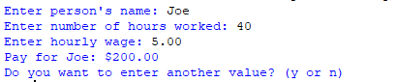

Exercise 2 (7): Shopping Cart

Write a program that checks out the items in the user’s cart on a shopping website. The program should use a class named Purchase to hold the information about a single item purchased (description, price, and quantity) and a class named Cart to hold a list whose items are objects of type Purchase. Use constructors where appropriate.

